Project Documentation

Last Updated: 12-03-19

1. Installation of IDE:

* + - Visual Studio 2017
    - SQL Server 2014
    - SQL Server Management Studio 2014

2. Practice Hands-On Visual Studio

3. Practice Hands-On MS SQL Server and SQL Server Management Studio

4. Connectivity with Nuget Packages for Nunit Testing

5. Installation of Nunit GUI

6. Developing Test Cases using Nunit for Sample Application

7. Running Test Cases using NUnit GUI

8. Project Layout (Modules and Functionalities)

9. Project Database Design

10. Project Testing (Develop Test cases using NUnit Testing Framework)

Installation of Visual Studio 2017

Step 1 - Download Visual Studio

Next, download the Visual Studio bootstrapper file. To do so , select the edition of Visual Studio 2017 that you want, click Save.

<https://visualstudio.microsoft.com/downloads>

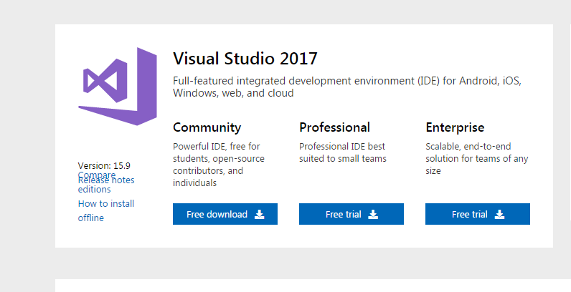

Step 2 - Install the Visual Studio installer

Run the bootstrapper file to install the Visual Studio Installer.

Run the bootstrapper that matches or is similar to one of the following files: vs_community.exe for Visual Studio Community

Step 4 - Select workloads

After the installer is installed, you can use it to customize your installation by selecting the feature sets—or workloads—that you want.

1. Find the workload you want in the Installing Visual Studio screen.

2. After you select the workload(s) you want, click Install.

3. Next, status screens appear that show the progress of your Visual Studio installation.

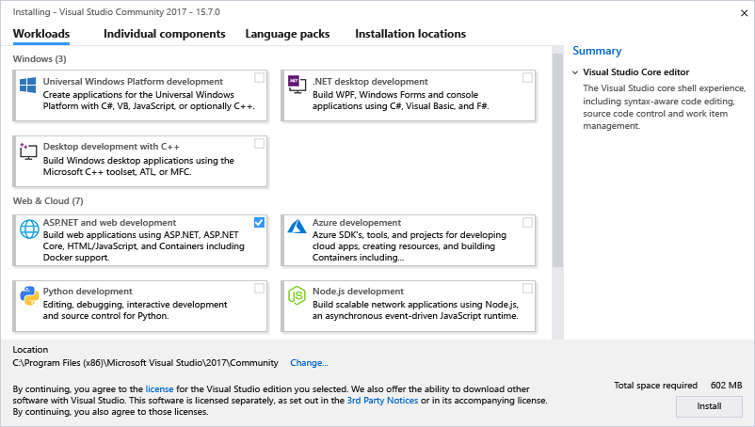

4. After the new workloads and components are installed, click Launch.

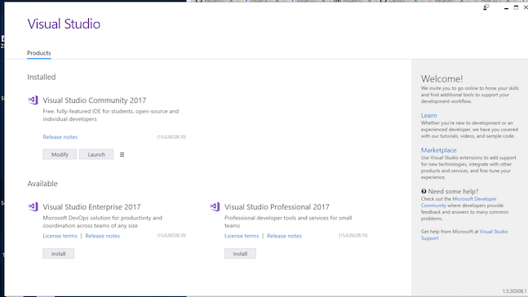

Step 5 - Start developing

* + After Visual Studio installation is complete, click the Launch button to get started developing with Visual Studio.
  + Click File, and then click New Project.
  + Select a project type.
  + To build a C# app, click Installed, expand Visual C#, and then select the C# project type that you want to build.

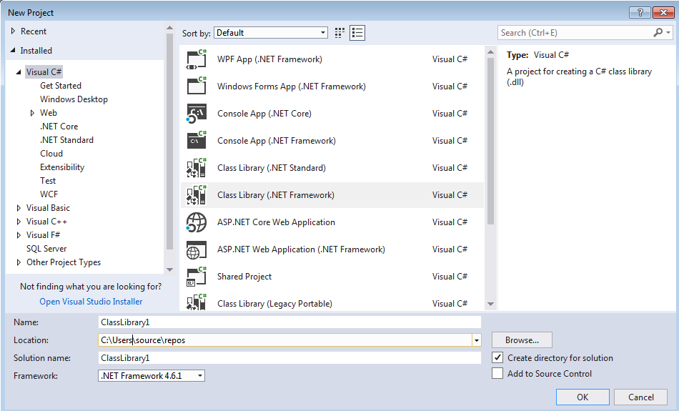

Installation of SQL Server 2014

Step 1 – Download the Microsoft SQL Server from official Microsoft Downloads.

(<https://www.microsoft.com/en-us/sql-server/sql-server-downloads> )

Select the SQL Server Express Edition for Microsoft Windows for your system architecture.

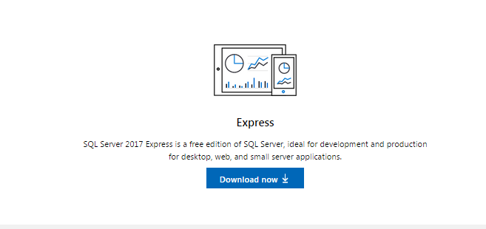

Step 2 - Click on the downloaded file and Run the file.

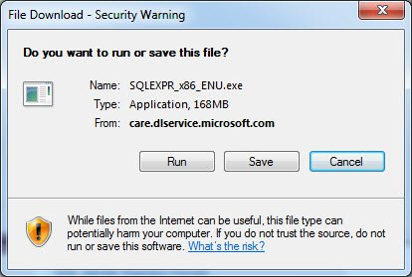

Step 3 - Accept the license terms and click next.

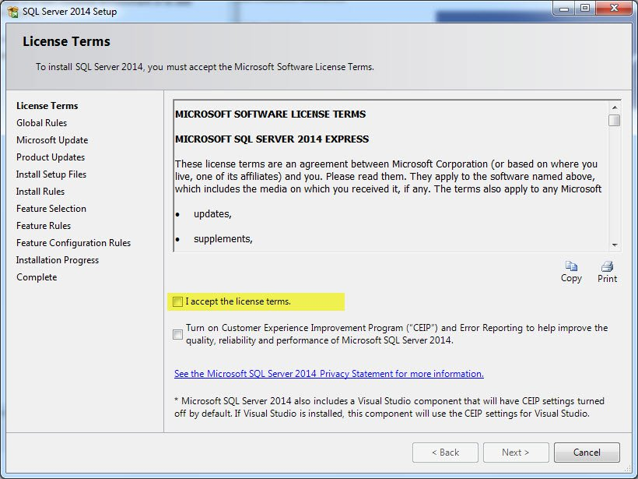

Step 4 -On the Feature Selection screen, keep the defaults.

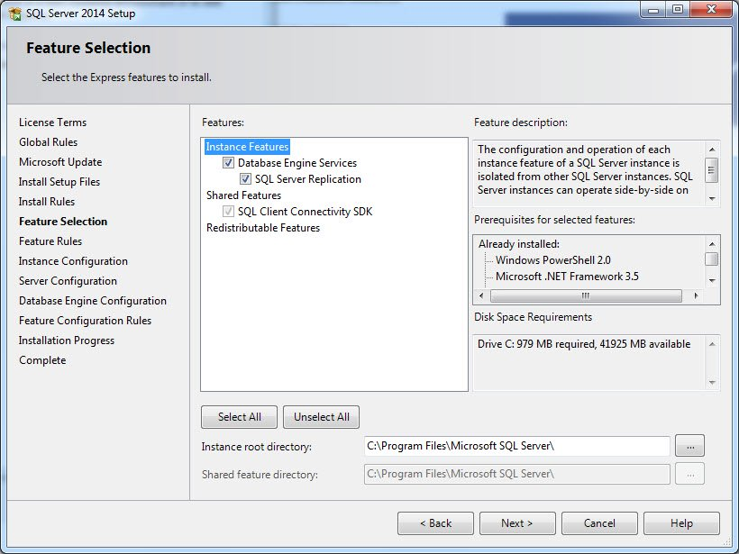

Step 5 – On instance configuration screen, select “**Named Instance**” and name the

Database you want and click.

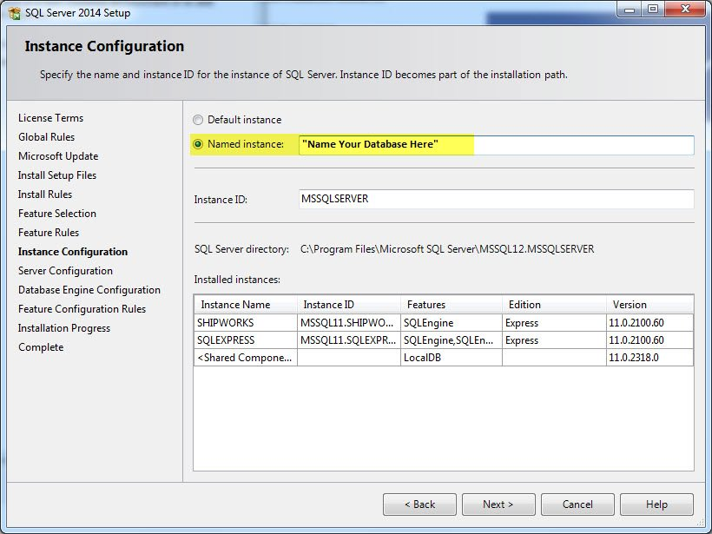

Step 6 - Click next until you get to the Database Engine Configuration screen and Select Windows Authentication Mode.

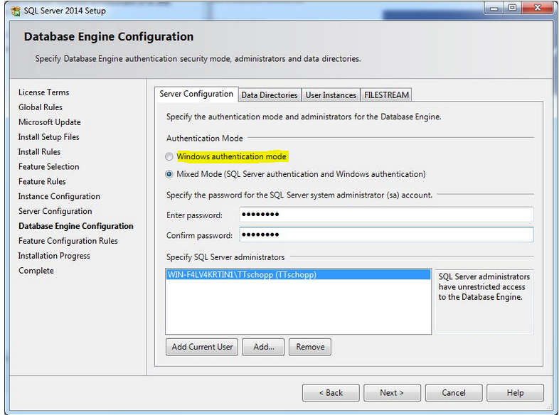

Step 7 - Click next until your setup is complete. Click Close.

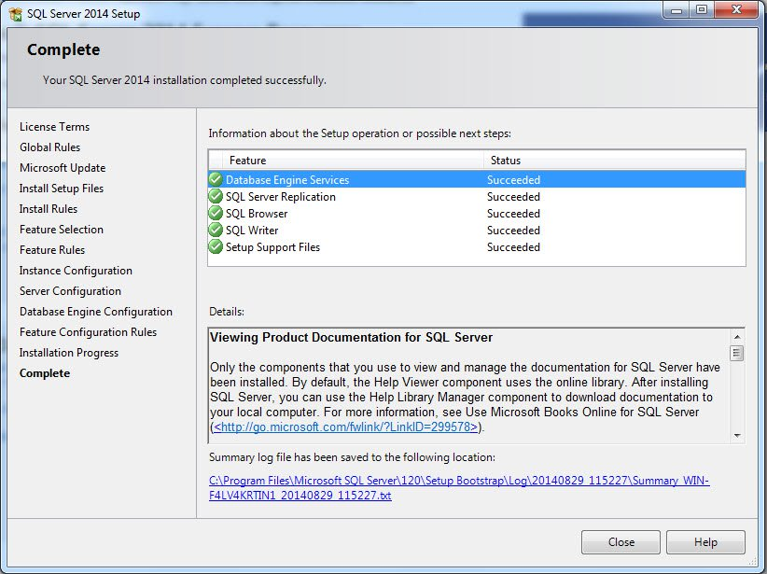

Installation of SQL Server Management Studio 2014

Step 1 – When SQL Server Installation Center is opens, choose “Installation” and

Then choose “Add features to Existing installation”.

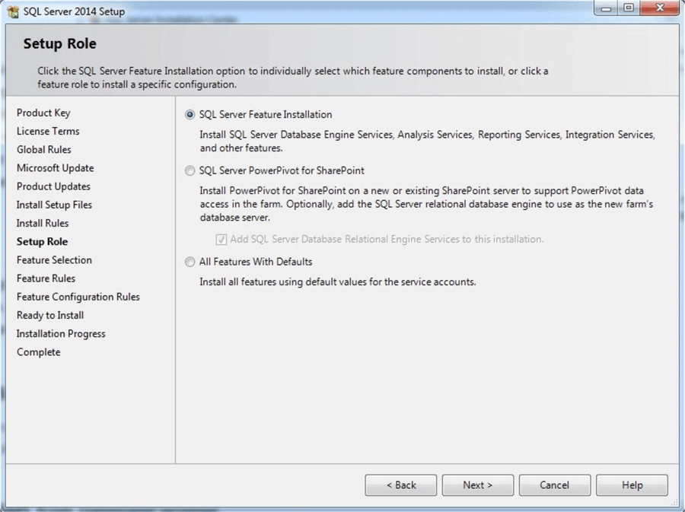

Step 2 - After clicking “Next” from the features list choose only “Management

Tools - Basic and Management Tools - Complete” as shown below:

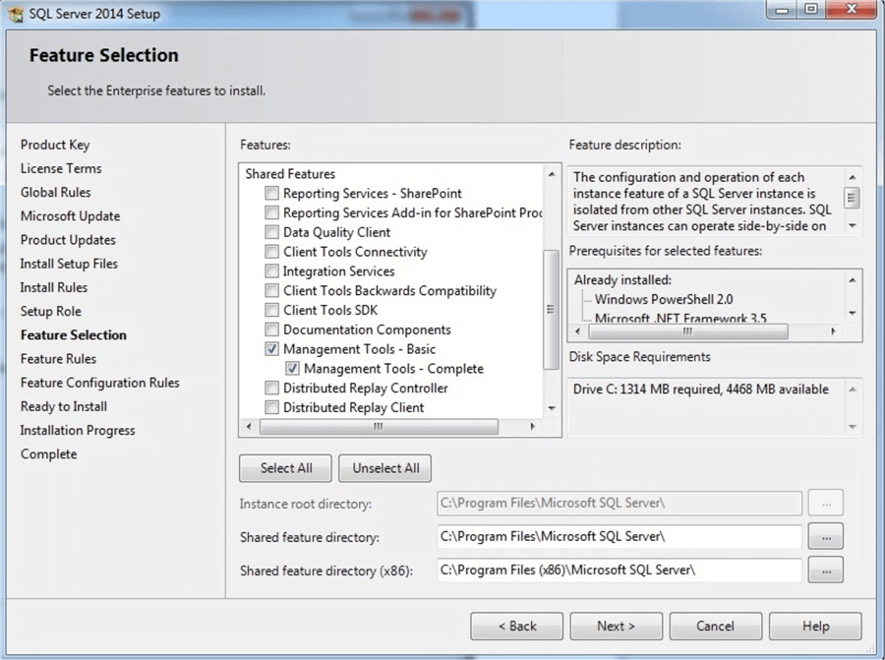

Step 3 - After pressing the “Next” button several times and accepting the license

Terms the “Ready to Install” window appears and Click on install. After

Installation Click Close.

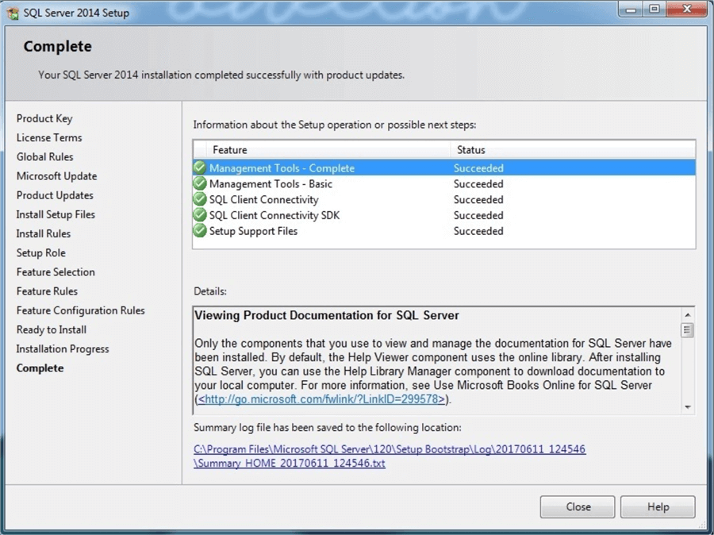

Practice Hands-On Visual Studio 2017

Aim – To develop a sample web application for practice for MS Visual Studio.

(Basic Calculator Web-Application)

1. Create a Visual C# Web Application (.NET Framework).

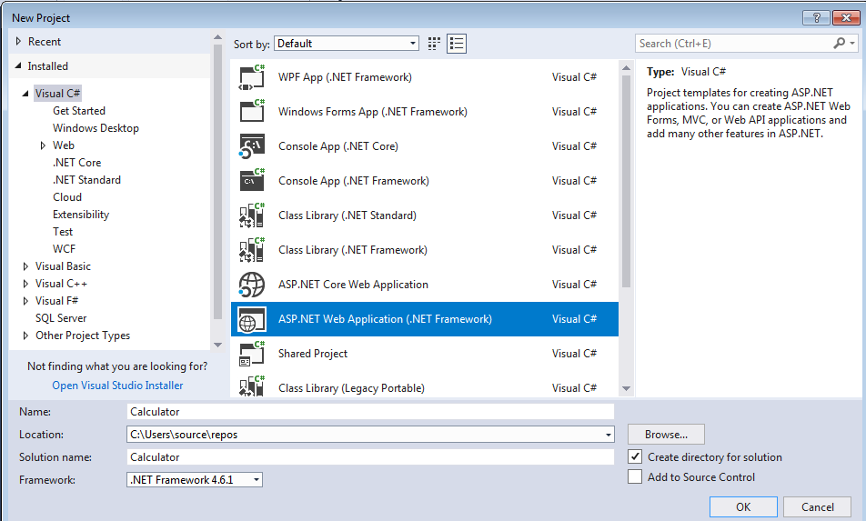

2. Create a Calculator User Interface.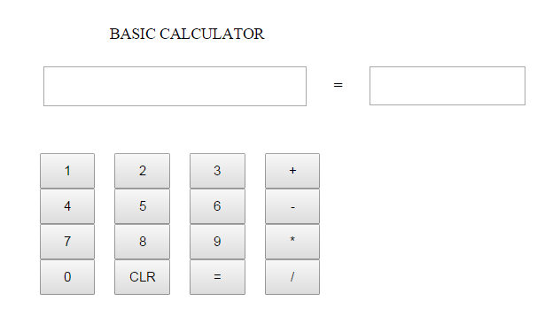

3. Write the methods for Calculator Class.

* Add
* Subtract
* Multiply
* Divide

4. Build and Run the Solution.

Enter any operation and click on ‘=’ to see the output.

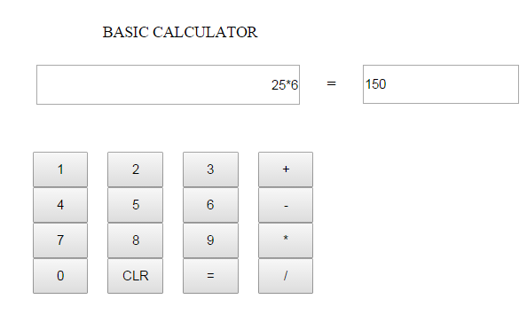

Practice Hands-On SQL Server and SSMS

Aim – To develop a sample Database for practice using SQL Server in SQL Server

Management Studio. (Knowledge Management System)

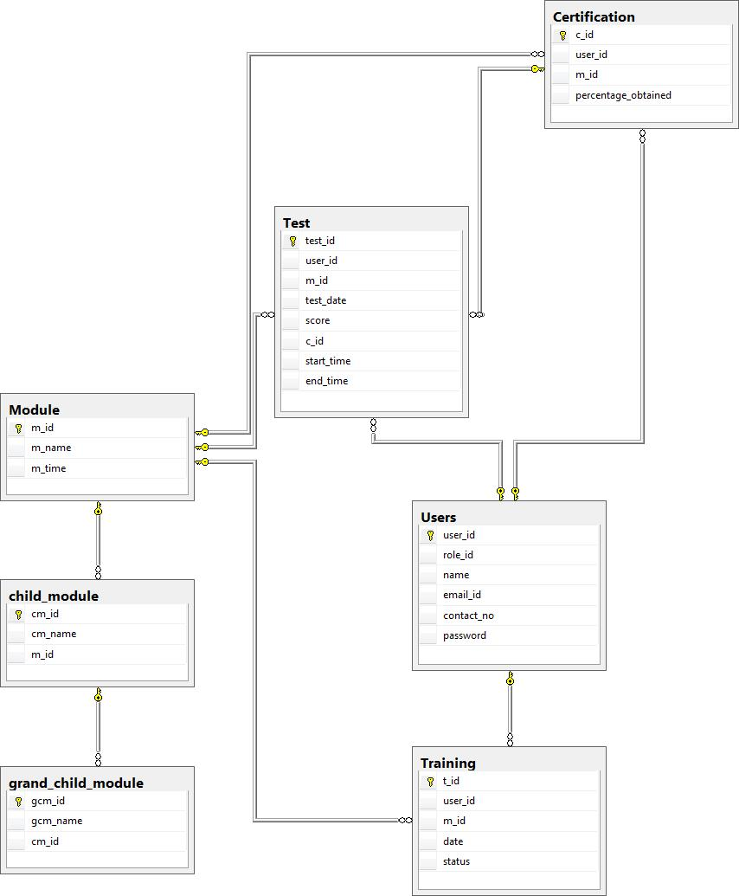

Connectivity with Nuget Packages for Nunit Testing

Aim - To install Nuget Packages for Nunit Framework in MS Visual Studio.

1. To install Nunit framework extensions, go to Tools -> Nuget Package Manager -> Manage Nuget Packages for Solution.

Install the following two extensions:

* NUnit
* NUnit3 Test Adapter

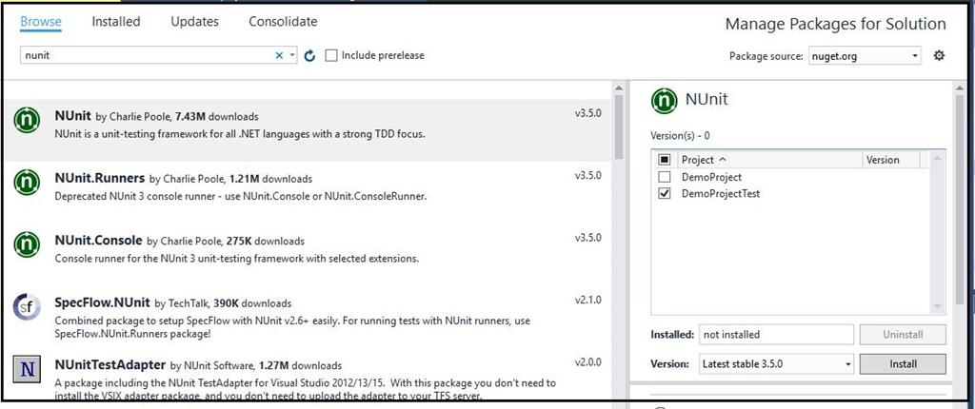

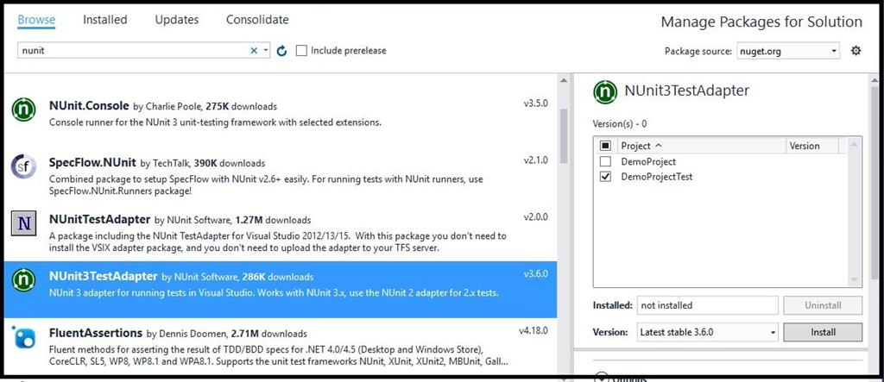

Installation of Nunit GUI

Step 1 - To install the NUnit GUI interface, go to the following download link:

<https://github.com/TestCentric/testcentric-experimental-gui/releases>

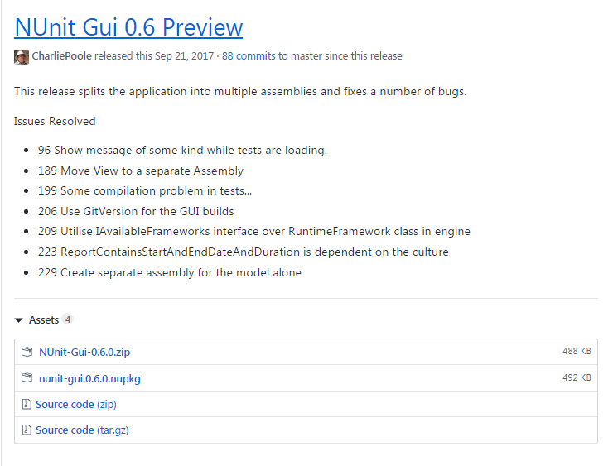

Step 2 - Download the [NUnit-Gui-0.6.0.zip](https://github.com/TestCentric/testcentric-experimental-gui/releases/download/0.6/NUnit-Gui-0.6.0.zip) from NUnit GUI 0.6 Preview.

Step 3 - Extract the ZIP file and run the application file nunit-gui.exe

Developing Test Cases using Nunit for Sample Application

1. Add the reference to following extensions in Test Project

* Nunit
* Nunit Test Adapter

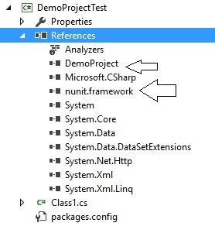

2. Add a reference to the sample project under test project

* Next, we need to add a reference to the Calculator project (system under test) in the test project.
* To add that right click on the test project and add a reference to the Calculator project.

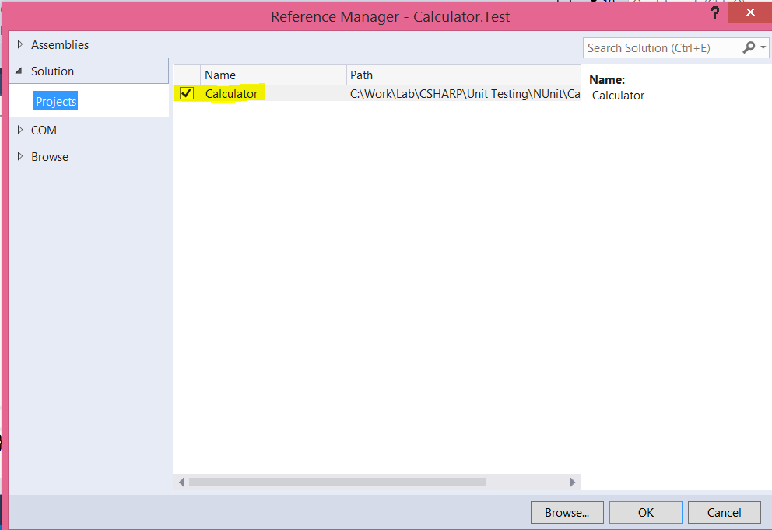

3. Add the line in the Test Methods file.

> using Nunit. Framework;

4. Write Test Cases in a Class file for the methods of the sample project.

* Write [TestFixture] above Class.
* Write [Test] above every method to be tested.

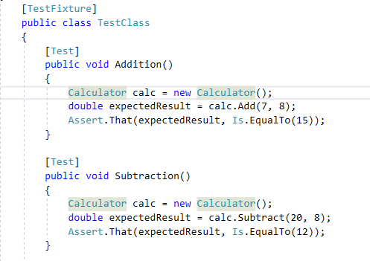

5. Go to Test->Windows->Test Explorer.

Click on Run All to execute all the test cases.

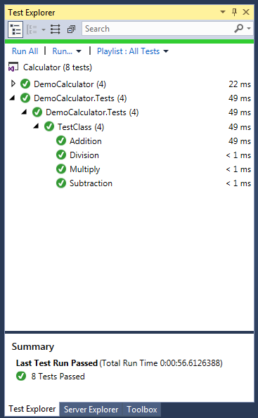

Running Test Cases using NUnit GUI

1. Run the application nunit-gui.exe.
2. Open new Project->Select the TestProject.dll file which contains the Test Cases.
3. Click on the RUN button to execute the Test cases.

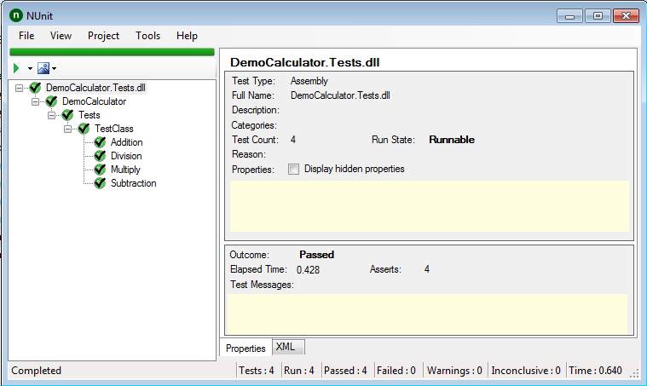

Project Layout (Modules and Functionalities)

1. Login Module

* Input: Username and Password.
* Output: Redirection to the Home Page.
* Description: User enters the login credentials for the user accounts ,on successful validation of user credentials the user is redirected to

Home page.

2. Registration module

* Input: User Details.
* Output: Redirection to the Login Page.
* Description: User enters the details for the creating new account ,on successful registration of user details the user is redirected to

Login page.

3. Generate Ticket module

* Input: Select the Ticket Request Type and enter required details.
* Output: Generation of the ticket and display ticket details.
* Description: User selects the appropriate ticket as per requirement, on successful generation of ticket the details are displayed.

4. Funds Transfer Module

* Input: User enters the Sender, Receiver Account details and Amount for the Funds Transfer.
* Output: Confirmation of successful addition of payee and redirect to Funds Transfer Page.
* Description: User enters the details for funds transfer, on successful transfer of funds, Transaction Details are displayed.

5. Add Payee-Details module

* Input: User enters the payee details to be added.
* Output: Confirmation of successful addition of payee and redirect to Funds Transfer Page.
* Description: User enters the new payee details to be added for Funds Transfer and on successful addition of payee the user is redirected to Funds Transfer page.

6. Account Summary module

* Input: User selects the account details for which transactions are to be displayed.
* Output: List of Transactions.
* Description: User is shown the summarized details of the transactions done.

7. Detailed-Statement module

* Input: User selects the transaction for which detailed transaction report is to be displayed.
* Output: Detailed statement of selected transaction.
* Description: User is shown the detailed statement of the transaction selected from the Account Summary.

Project Database Design

Database Name: bank

Tables:

1. Account

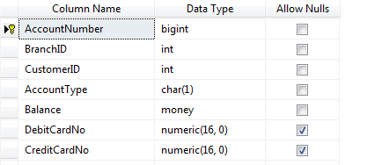

2. Admin

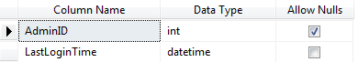

3. Branch

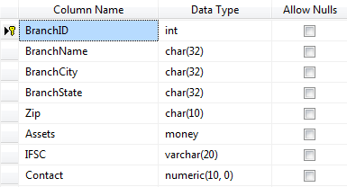

4. Customer

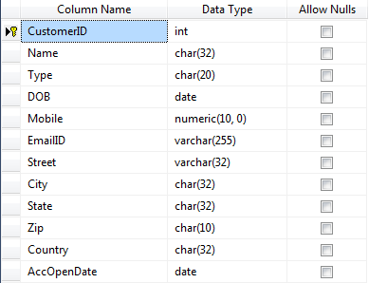

5. Loan

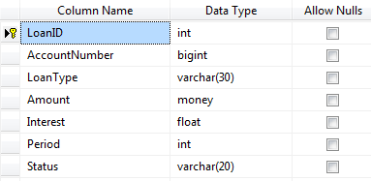

6. Loan Payment

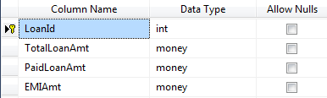

7.Login

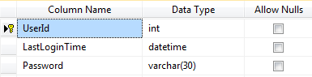

8. Registered Payee

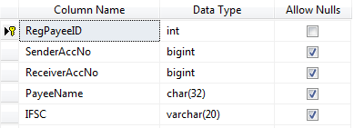

9. Request

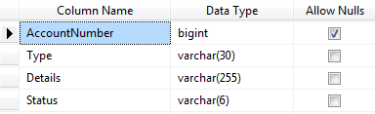

10. Transaction

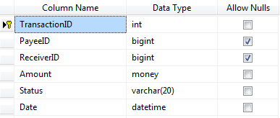

Project Testing (Develop Test cases using NUnit Testing Framework)